**USE CASE: Receive a Redline**

Document History

Document Location

This is a snapshot of an on-line document. Paper copies are valid only on the day they are printed. Refer to the author if you are in any doubt about the currency of this document.

The source of the document will be found …

Revision History

|  |  |  |
| --- | --- | --- |
| Revision Number | Revision Date | Summary of Changes |
| 1.0 | 8/14/2013 | Initial document |
|  |  |  |
|  |  |  |
|  |  |  |
|  |  |  |

Approvals

This document requires following approval signature. Signed approval forms are filed in …

|  |  |
| --- | --- |
| **Name** | **Title** |
|  |  |
|  |  |
|  |  |
|  |  |

Distribution

This document has been distributed to:

|  |  |
| --- | --- |
| **Name** | **Title** |
|  |  |
|  |  |
|  |  |
|  |  |

Contents

1. Introduction 5

1.1 Purpose 5

1.2 References 5

1.3 Notation/Structure 5

2. Use Cases 6

2.1 Use Case Name: Start a free trial 6

2.1.1 Use Case Overview…. 6

# Introduction

Use Cases are detailed descriptions of how users and systems interact with an application. These descriptions include ideal paths with alternate paths and post conditions. This information assists the structure and interface design for the best possible experience for the site’s users. Additionally, the Use Cases are used by the QA team to ensure all objectives and requirements were met and fulfilled successfully.

A set of Use Cases can be created to describe the majority of user interactions with the application. The Use Case will ultimately drive the User Experience team in defining the interface. With a clear distinction between user and system interactions written in use case form the UI can be developed in more detail.

Each Use Case follows and tracks back to business requirements.

## Purpose

This document describes the Use Cases for the outlined system.

Use Cases are used to explore and communicate the likely actions of users and the system when interacting with the application. Development of Use Cases helps the design team understand the business requirements and how they can ultimately drive the design and user experience.

## References

This document is based on the following documents:

* Document Name

## Notation/Structure

Use Cases typically have the following sections:

1. Overviews
2. Preconditions
3. Triggers
4. Main Flows
5. Alternate Flows
6. Business Rules
7. Messages (system generated)

# Use Cases

## Use Case Name: Receive a redline

### Use Case Overview….

|  |  |  |
| --- | --- | --- |
| **Use Case ID** | **Receive a redline** | |
| **Use Case Overview** | When a prospective customer sends back a redlined version of a document that was issued, the received document is uploaded to Cosentium. The system identifies the baseline document, and the changes that have been made. The system then organizes the review process and notifies users that need to participate.  This use case document describes uploading the received document, determining baseline, determining changes, starting workflow, notifying users, and storing the received file. | |
| **Precondition** |  | |
| **Trigger(s)** |  | |
|  | | |
| **B - Main Flow: Issue a deal** | | |
|  | B1 | "Deals" page  From the "Deals" page as described in B1 of "issue a deal" use case, user clicks through hypertext formatted Deal Name for a previously created deal.  User lands on "Deal Detail" page |
|  | B2 | "Deal Detail" page  The page title of "Deal Detail" displays. Beneath this is a primary content container. Inside of this is a secondary content container. Inside the secondary content container, is the subtitle text of "Deal Data". Underneath this text is a content container containing the following fields and corresponding data: "Deal Name:" (friendly deal name), "Deal Owner:" (the owner of the deal and their profile picture), "Current Turn:" (the number of the current turn that the deal is on- see step B2 in "use case issue a deal 08132013" for details on how the system should infer the current turn number), "Master Document:" (the master document that was used to create the deal), "Total Elapsed Time:" (the amount of total time that has elapsed since the deal was first issued to the customer). Underneath the content container containing these fields is an action button labeled, "Upload Customer Response Document". If the user is the owner of the deal, this button is available to be clicked. If the user is not the owner, the button is not available to be clicked (i.e grayed out or otherwise disabled)  Underneath this is another secondary content container. Inside the content container is the subtitle text of "Deal History". Underneath this text is a content container that contains a table with 6 columns. The first column header is titled, "Turn". The second column header is titled, "Stage". The third column header is titled, "Date". The fourth column header is titled, "Material Changes". The fifth column header is titled, "Non-Material Changes". The sixth column header is titled, "Total Changes". Under the "Turn" column, the turn # corresponding to each data row is displayed. Under the "Stage" column, the stage associated with each turn is displayed. Underneath the "Date" column, the date on which the turn document was issued or received is displayed. Under the "Material Changes" column, the number of material changes for the corresponding turn document is displayed as determined by the legal admin/manager that processed the turn document for non-material changes. Under the "Non-Material Changes" column, the number of non-material changes for the corresponding turn document is displayed as determined by the legal admin/manager that processed the turn document for non-material changes. Under the "Total Changes" column, the total number of changes for the corresponding turn document is displayed. This is determined by the system. This should equal the number non-material changes plus the number of material changes for a given turn document. Underneath the content container containing this table are four action buttions: "Audit", "Status", "View File", "View Sent Email". See VR1 for a sample UI treatment.  Underneath the content container which holds the table and action buttons is an action button labeled, "Done"  If the user clicks "Audit", then take the user to the flows to be defined in "audit a review" use case.  If the user clicks "Status", then take the user to the flows to be defined in "check deal status" use case.  If the user clicks "View File", then spawn a new window and display a non-editable version of the issued or received file.  If the user clicks "View Sent Email", then @  If the user clicks "Done", then return the user to step B1.  User clicks "Upload Customer Response Document" |
|  | B3 | "Upload received response document"  The "Upload received response document" page contains title text of "Upload Received Response Document". Underneath the title text is a content container. Inside the content container is the text, "1. Select the File". Below this is the text, "Type the path of the file or click the Browse button to find the file". Below this an action button labeled, "Choose File". Below this is the text, "2. Click the Attach File button". Beneath this is the text, "When the upload is complete, a summary page will display." Below this is an action button labeled, "Attach File". The "Attach File" button is only available to click after a file has been chosen in step 1. See VR2 for a sample UI treatment.  The user clicks the "Choose File" button, selects the file to be uploaded. The file name displays to the right of the "Choose File" button.  The user clicks the "Attach File" button and lands on the "Confirm Received Response Document" page. |
|  | B4 | "Confirm Customer Response Document" page  The page title text of "Confirm Customer Response Document" is displayed. Beneath this title text is a primary content container. Inside the content container is another secondary content container. Inside this content container is the text, "You have just uploaded the following file:". Underneath this, the text, "File:<uploaded file name>" displays. Underneath this, the text, "Size: <uploaded file size>" displays. Below the secondary content container, and within the primary content container, is another secondary content container. Inside this content container is the text, "Deal relationship details:". Beneath this, there is a data entry field containing the Deal Name selected by the user, and a field label to the left of it with text, "Deal Name". The field is not editable by the user. Beneath this is a data entry field containing the stage of the file/turn the upload was derived from. There is a field label to the left of this with text, "Upload is a response to:". To the right of the data entry field containing the stage of the file/turn the upload was derived from, is the filename of the file the upload was derived from, displayed in parentheses. The stage and filename are not editable by the user. Beneath this are two action buttons, the first labeled "Confirm" and the second labeled "Cancel" and placed to the right of it. Please see VR3 for a sample UI treatment.  If the user clicks "Cancel", deliver them to step B3.  User clicks "Confirm" and the user is delivered to "Start Review Process" page. |
|  | B5 | The "Start review process" page  The "Start Review Process" page displays after system does comparison against the last issued document for the deal, calculates number of changes, looks up the workflow, describes how the review process will work (i.e. non material changes, then material changes, after which the salesperson gets to review everything and release to legal for drafting). It summarizes all this for the user to review and asks the user to click on "Start Review Process" (which in the case of our default workflow, will result in a message to the legal admin to process out all the non-material changes).  The page title text of "Start Review Process" is displayed. Beneath this title text is a primary content container. Inside the primary content container, is a secondary content container. Inside the secondary content container, a data field displays the number of changes found, and left of the data field, text of "Changes Detected:" displays. The data field is not editable by the user. Below the secondary content container is another secondary content container. Inside this secondary content container, is header text of "Review Process:". Under this text, there is text of "First:" To the right of this is the text, "Non-material changes will be processed." To the right of this, the text "<SLA> or less" is displayed. In the case where the step will be completed bya single user, the SLA is the SLA on file for that user. In the case of multiple users, the SLA is the longest SLA for any user that will need to provide a decision as part of the review process. Under this text, there is text of "Second:" To the right of this is the text, " Opinions and decisions will be collected on all remaining changes." To the right of this, the text "<SLA> or less" is displayed. In the case where the step will be completed bya single user, the SLA is the SLA on file for that user. In the case of multiple users, the SLA is the longest SLA for any user that will need to provide a decision as part of the review process. Under this text, there is text of "Third:" To the right of this is the text, " You will review all the decisions and authorize them to be translated into "legalese"." To the right of this, the text "<SLA> or less" is displayed. In the case where the step will be completed bya single user, the SLA is the SLA on file for that user. In the case of multiple users, the SLA is the longest SLA for any user that will need to provide a decision as part of the review process. Under this text, there is text of "Fourth:" To the right of this is the text, "A response document will be made. You will be notified when it's ready to issue." To the right of this, the text "<SLA> or less" is displayed. In the case where the step will be completed bya single user, the SLA is the SLA on file for that user. In the case of multiple users, the SLA is the longest SLA for any user that will need to provide a decision as part of the review process.  Underneath this secondary content container is the text, "You can check the status of the review any time". Underneath this is another line of text, "You can audit the progress of the review process any time." Underneath the primary content container are two action buttons, the first labeled "Start Review Process" and a second labeled "Cancel" just to the right of it.  Please see VR4 for a sample UI treatment.  If the user clicks "Cancel", display a toast, "Are you sure? Your work will be discarded."  If the user clicks "Start Review Process", then workflow commences with a work item created and a corresponding notification sent to the legal admin/manager to do a review in order to factor out all the non-material changes)- to be described in "review a deal" case. |
| **Post-**  **conditions** | * Uploaded file stored according to storage mask * Uploaded file compared to baseline, changes identified * Workflow identified (only one by default for now) * List of reviewers determined along with the list of changes that each reviewer must provide an opinion or decision on | |
|  | | |
|  | | |
| **A1** |  | |
|  | A1.1 |  |
|  | A1.2 |  |
| **Post-**  **conditions** |  | |
|  | | |
| **A2** |  | |
|  | A2.1 |  |
|  | A2.2 |  |
| **Post-**  **conditions** |  | |
|  | | |
| **A3** |  | |
|  | A3.1 |  |
|  | A3.2 |  |
|  | A3.3 |  |
| **Post-**  **conditions** |  | |
| **A4** |  | |
|  | A4.1 |  |
| **Post-**  **conditions** |  | |
| **A5** |  | |
|  | A5.1 |  |
| **Post-**  **conditions** |  | |
|  | | |
| **Messages** | M1 |  |
|  |  |  |
|  |  |  |
|  |  |  |
|  |  |  |
|  |  |  |
|  |  |  |
|  |  |  |
|  |  |  |
|  |  |  |
|  | | |
| **BRs** | 1 |  |
|  | 2 |  |
|  | 3 |  |

Q&A

|  |  |  |  |
| --- | --- | --- | --- |
| **Question** | **Question Date** | **Answer** | **Answer Date** |
| How will a salesperson check on the status of a deal? |  | Deals, click through Deal Name, see Deal Detail page where the user can choose "Status" of the current step, "Audit" of the progress of current step, and so on |  |
| How will a salesperson or any other user with adequate permissions audit the progress of a deal |  | Deals, click through Deal Name, see Deal Detail page where the user can choose "Status" of the current step, "Audit" of the progress of current step, and so on |  |
|  |  |  |  |
|  |  |  |  |
|  |  |  |  |
|  |  |  |  |
|  |  |  |  |
|  |  |  |  |
|  |  |  |  |
|  |  |  |  |

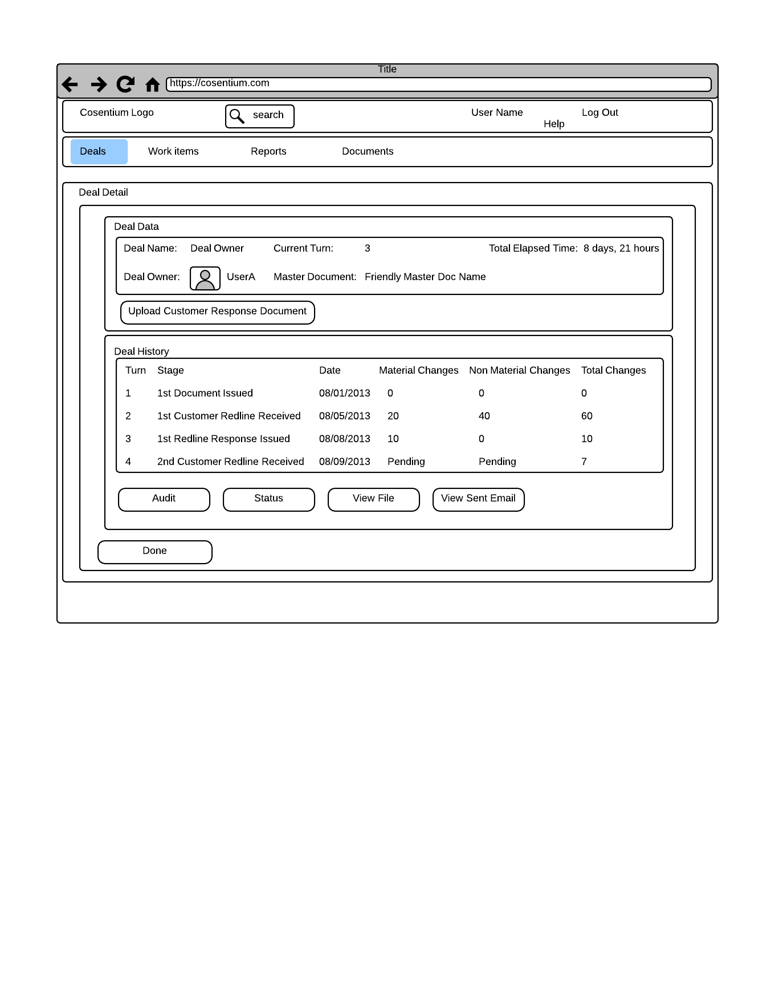

VR1: "Deal Detail - New Page.png"

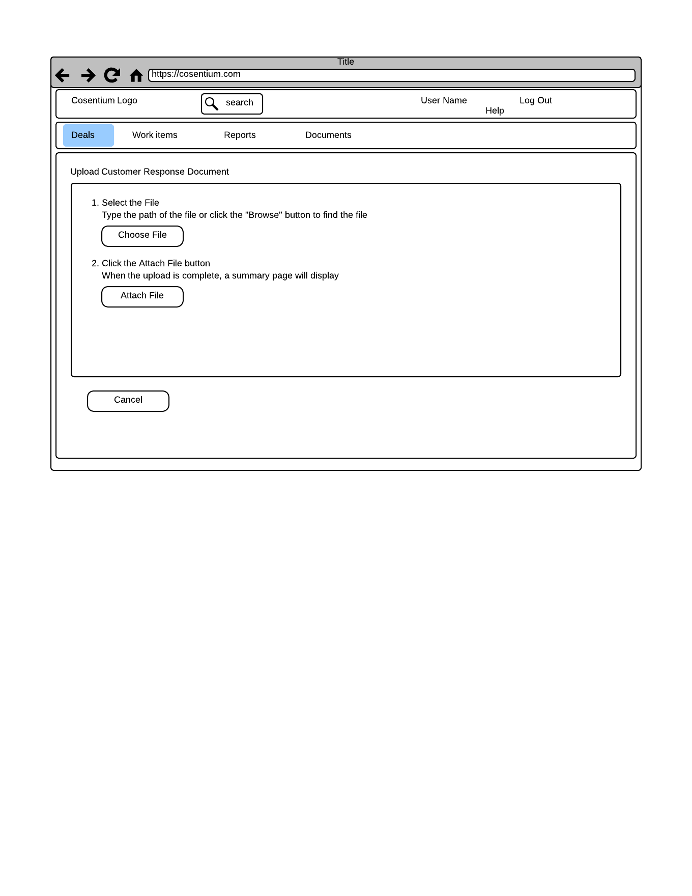

VR2: "Upload Customer Response Document.png"

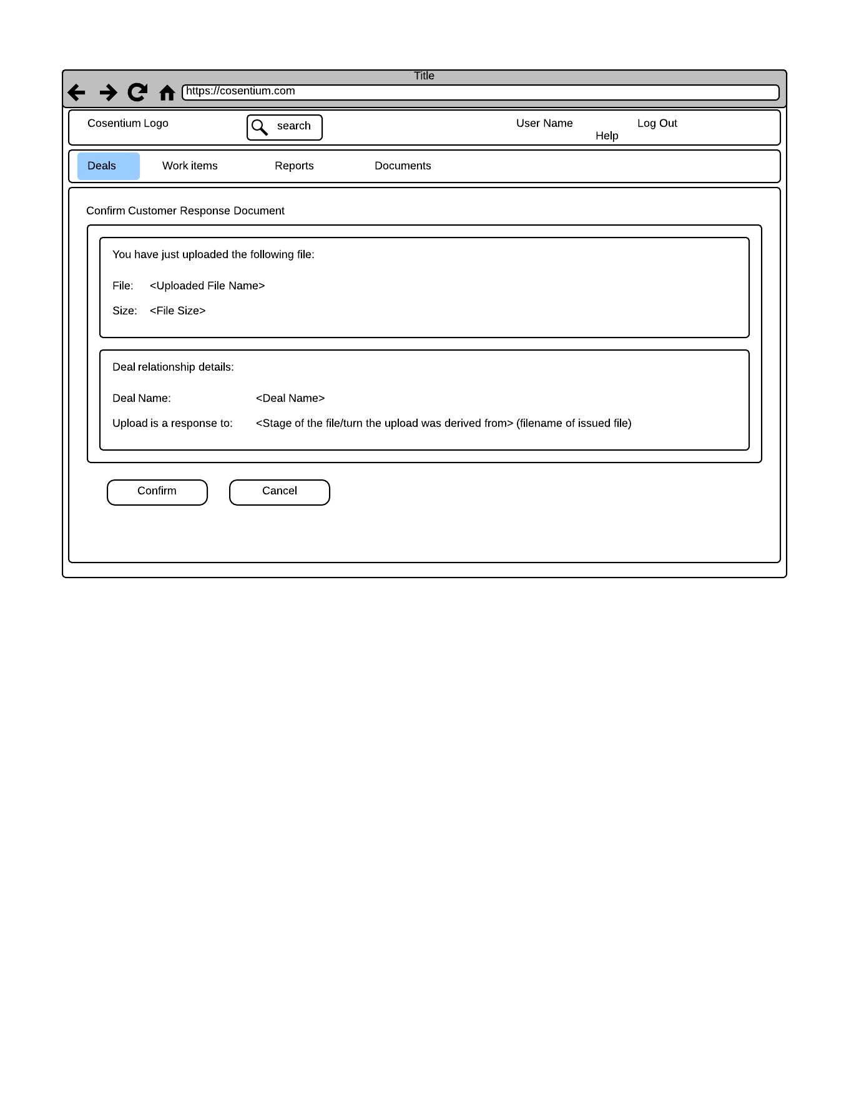

VR3: "Confirm Customer Response Document - New Page.png"

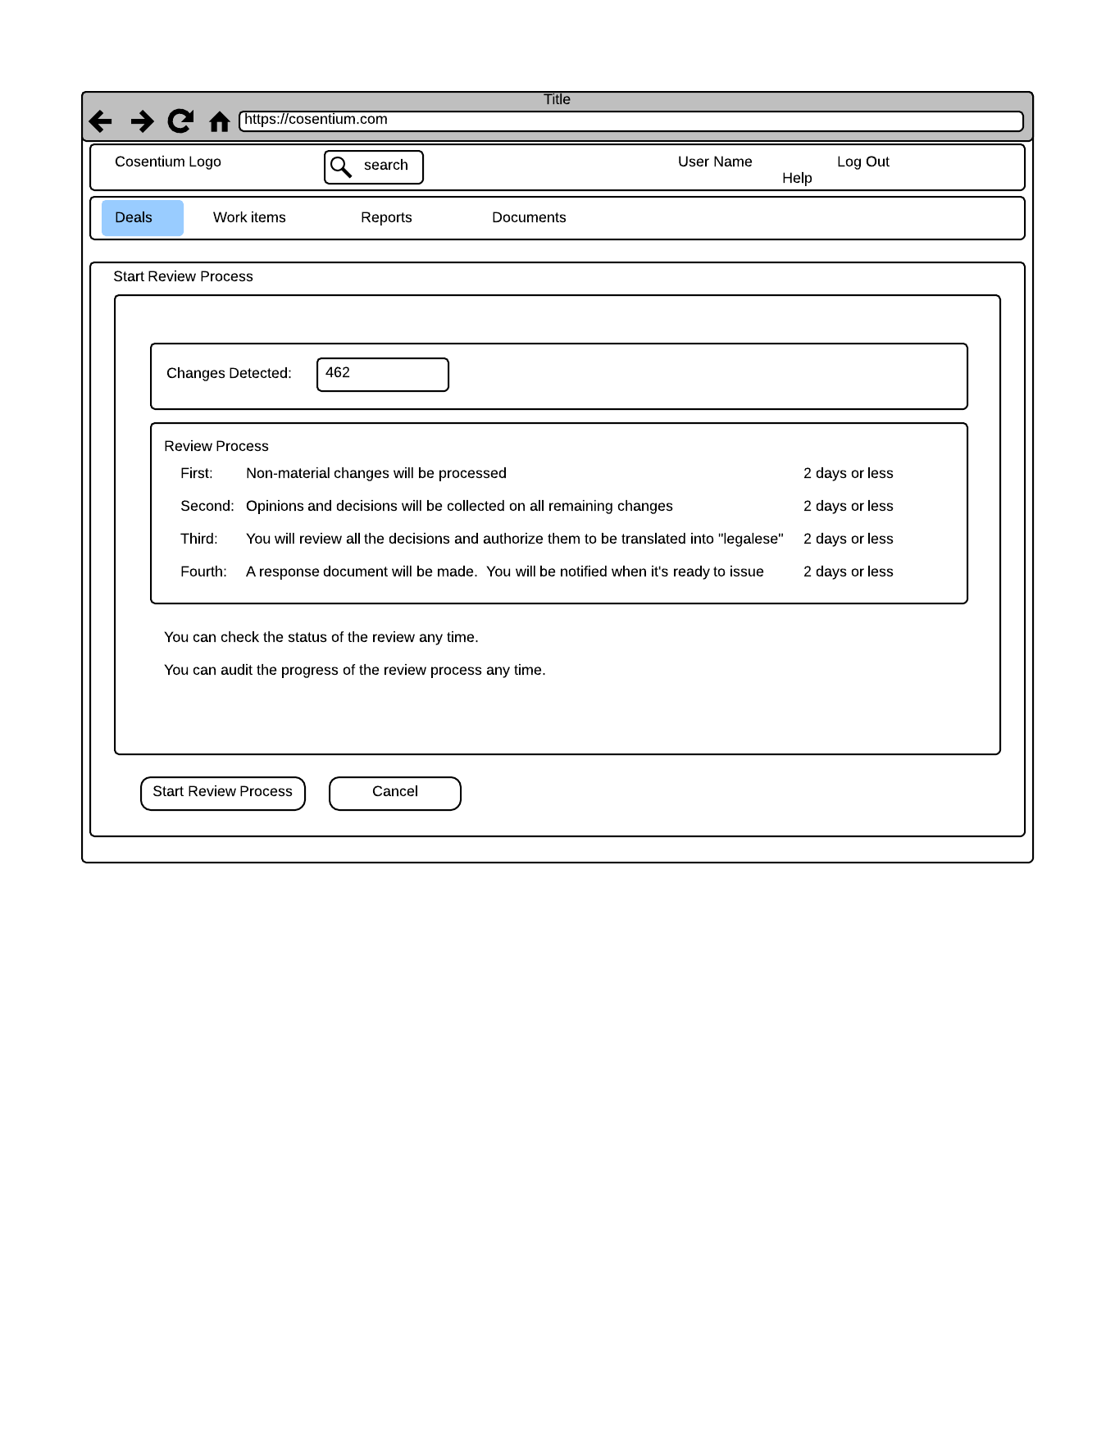

VR4: "Start Review Process - New Page.png"